Sunset Palms Turtle Talk
Karen Riddle, Principal Justin Gamelin, Assistant Principal Sunset Palms is an “A” rated and 5 Star School April 1, 2024
IMPORTANT PHONE NUMBERS  Main Office 752-1100  Clinic 752-1121 (Nurse Linda)  After the Bell 752-1135 (Mrs. Baumgardner)  ESE Contact 752-1112 (Mrs. Janisko)  Data Processor 752-1102 (Ms. Navarrete)  Guidance 752-1117 (Ms. Marcus)  Cafeteria 752-1156 (Kinia Estime)  IMPORTANT DATES  April 3 – Bike/Walk to School Day  April 8 – 19 – Jump Rope for Heart during P.E.  April 9 – KG Round-Up – 2 Sessions:  Session 1 - 8:30 - 9:30 a.m.  Session 2 - 5:30 – 6:30 p.m.  For more information, please see blurb at the bottom of the middle column.  April 10 – No School  April 12 – Progress Reports Posted to SIS  April 17-24-Book Fair  April 25 – Take Your Child to Work Day  DISTRICT POLICY/SAFETY  Students may not bring knives to school for any reason, which means please do not pack knives in your student's lunch box to use for lunch or snack.  .  - INSTANTLY ALERT LAW ENFORCEMENT ABOUT SUSPICIOUS ACTIVITY & THREATS  - INCLUDE PHOTOS AND VIDEOS EASILY  - REMAIN ANONYMOUS  See Something, Say Something, DO SOMETHING  CELL PHONES/WIRELESS COMMUNICATION DEVICES  We follow SB policy 5.183 for students.  Elementary school students may possess cellular phones and other wireless communication devices on school property and school-sponsored transportation, provided such devices are not visible, used, or activated, and are kept in the "off" position throughout the instructional school day and while on school-sponsored transportation. Students must keep their cellular phones and other wireless communication devices stored in their backpack, or other non-visible secure location during the instructional school day and while on school-sponsored transportation.  AUTISM SPEAKS WALK  Congratulations to our ASD team! Our team raised the 2nd most of any team in the entire Autism Speaks Walk- $17,700, and they had the most walkers…over 100. Way to go Sunset Palms!!! | DRESS CODE POLICY - IMPORTANT  We have a mandatory dress code at Sunset Palms. ALL students are expected to be in dress code daily. No stripes, patterns, designs. Please see the details below.  The policy sets guidelines for students to create an atmosphere that fosters learning without fashion distractions and safety hazards. Students who DO NOT adhere to the dress code policy will receive an area of concern on the “Follows rules/routines/directions” section on the report card. Please contact the front office if you need assistance with obtaining dress code items. Shirts with logos may be purchased through our PTA. Other school dress code items may be purchased at any retail store.  Tops – Solid collared shirts (Any color, short sleeve or long sleeve, with or without the Sunset Palms logo). The Sunset Palms logo is preferred. No stripes, patterns or designs.  Sweatshirts- Solid color (free from decorations and writing) sweatshirts may be worn over the collared shirts in the classroom.  Bottoms –Pants, capris, shorts, skirts, leggings and skorts (solid khaki, navy, black). No stripes, patterns or designs.  Uniform Jumpers – Plain solid collared shirt underneath.  Uniform Polo Dresses – Solid colors.  Jackets - Solid jackets (free from decorations and writing) may be worn over the collared shirt in the classroom. Other types of jackets may be worn to school and outside, but may NOT be worn in the classroom.  Not permitted – Midriff baring, short shorts, short skirts, short skorts, athletic shorts, flip flops, open toed, open heeled or platform shoes. Dress code clothes should not be cut, bedazzled, etc. Shoes must be closed toe and closed heel for safety reasons.  Fridays ONLY – Jeans may be worn with dress code top  ****ID Badges MUST be worn daily.****  DROP OFF/PICK UP  When dropping off students and/or picking up students, please use both lanes entering the school and merge at the cones to avoid backing up traffic on Acme Dairy. Please be courteous to others in the car loop. Thank you for your cooperation!  KINDERGARTEN ROUND-UP!  Tuesday, April 9 we will be holding 2 sessions of Kindergarten Round-Up, in our cafeteria, for parents of incoming Kindergarten students. Here are the following times:  - 8:30 - 9:30 a.m.  - 5:30 – 6:30 p.m.  Please select a time that is convenient for you and RSVP to daniella.navarrete@palmbeachschools.org.  CAREER WEEK!  Sunset Palms Elementary will focus on Career Awareness during the week of Monday, April 22, 2024 -Friday, April 26, 2024. We are looking for parents to volunteer and present to their child’s classroom. Please contact your child's teacher for more information. | UPCOMING TENTATIVE TESTING DATES  The following are tentative testing dates for students in K through 5. If there are any changes we will send an update.  Gr KG ELA-4/18 Gr 4-Writing-4/4  Gr K Math-5/3 Gr 4 ELA-5/8  Gr 4 Math-5/16  Gr 1 ELA-4/17  Gr 1 Math-5/2 Gr 5 Writing-4/5  Gr 5 ELA-5/9  Gr 2 ELA-4/16 Gr 5 Math-5/14  Gr 2 Math-4/30 Gr 5 Science-5/17  Gr 3 ELA-5/1  Gr 3 IReady-Week of 5/6  Gr 3 Math-5/15  NEW VOLUNTEER MANAGEMENT SYSTEM  The School District of Palm Beach County implemented our new Volunteer Management System back on March 25, 2024. All present volunteers must complete the new volunteer application before you arrive to volunteer (now available on any mobile device!). Please scan the QR code below to get started! After the front office has successfully scanned your government-issued ID, you can use the volunteer Kiosk located in the school's front office to sign in AND sign out. If you have any questions, please reach out to our school volunteer coordinator Daniella.navarrete@palmbeachschools.org.  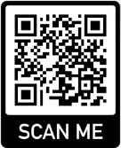  SCHOOL DISTRICT OF PALM BEACH COUNTY ELEMENTARY MATHEMATICS, SCIENCE, AND STEM VIRTUAL SHOWCASE OF PROJECTS  Congratulations to Hasya Reddy Maram, Kavya Pandit, and Micah Bartolini for submitting projects which have been selected to be showcased in the School District of Palm Beach County Elementary Mathematics, Science, and STEM Virtual Showcase of Projects this year! We are so proud of their hard work and accomplishments! Way to go!  CLASS PLACEMENTS FOR 2024-2025  We have wonderful teachers at Sunset Palms Elementary. There is NO need to send in teacher requests; we cannot guarantee a specific teacher. Your child’s teacher will contact you the day before Meet the Teacher in August.  SCHOOL WEBSITE LINK  http://www.palmbeachschools.org/sunsetpalmselementary
Spirit Night at Adrenaline!  Join us for Spirit Night at Adrenaline in  Canyon Town Center on  Friday, April 19 from 4:00-8:00 p.m.!  A percentage of the sales will be donated back to  Sunset Palms Elementary.  We can’t wait to see you there!  Thank you for supporting our school!  *****************************************************Scan the QR Code below to visit PTA’s online store!  Shop spirit wear, uniforms, and more!  ​​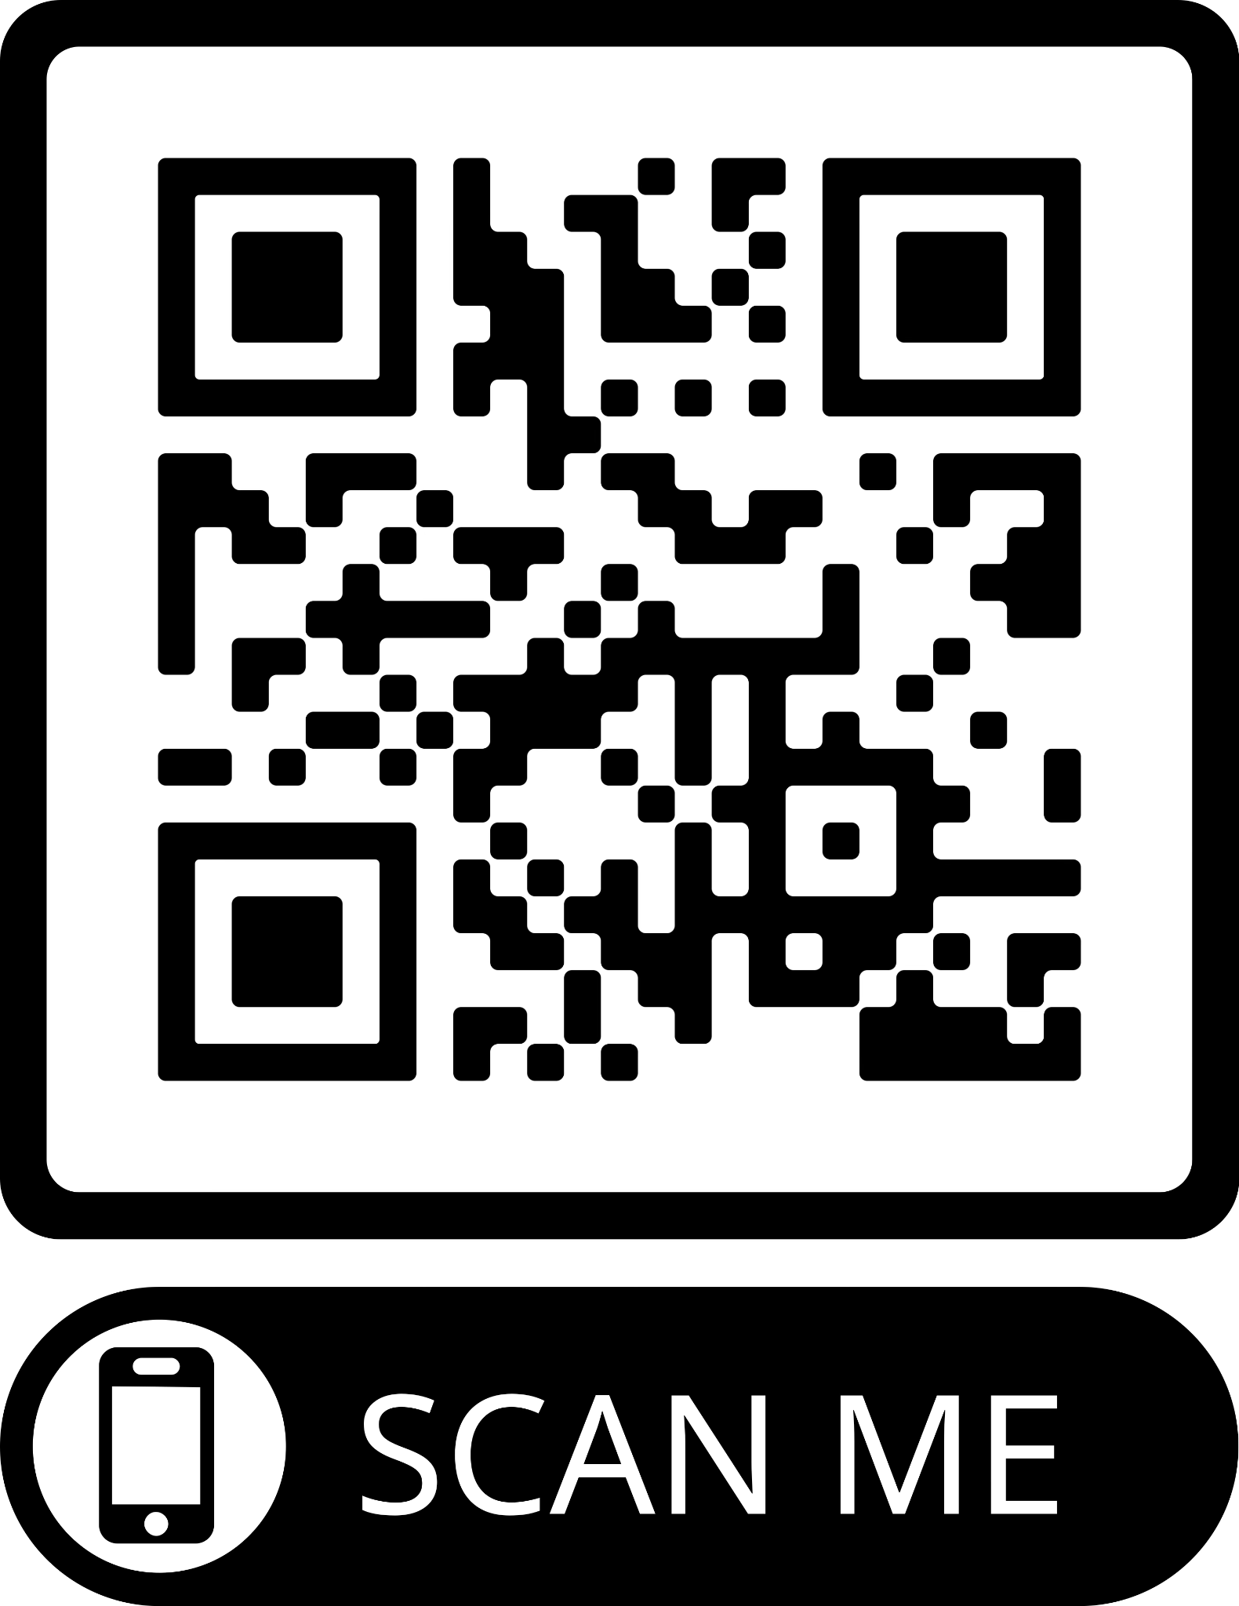  *****************************************************  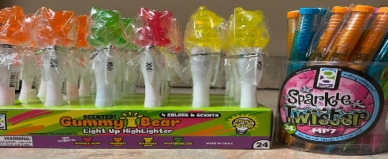  Student Store  Our Student Store is open for business on designated Fridays from 7:25 a.m.-7:50 a.m. at the back of the Main Hall, offering Spirit Sticks, Smencils, cute erasers, fidgets, Scented Gel Pens and more!  Birthday Bucks may be used here.  *This is a student only event*  *****************************************************  Let’s Stay Connected!  Visit our website: www.SunsetPalmsPTA.com  Sign up for our emails: Text SPEPTAINFO to 22828  LIKE AND FOLLOW US ON SOCIAL MEDIA! | PTA NEWS  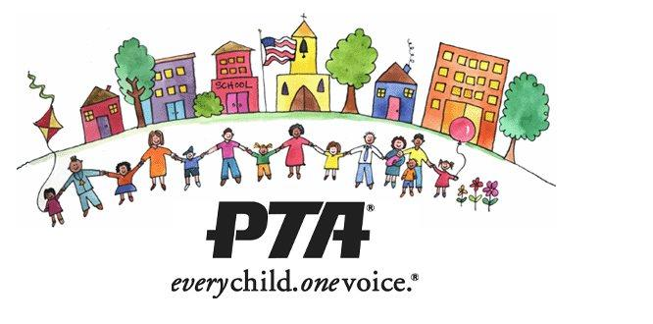  **********************************************************  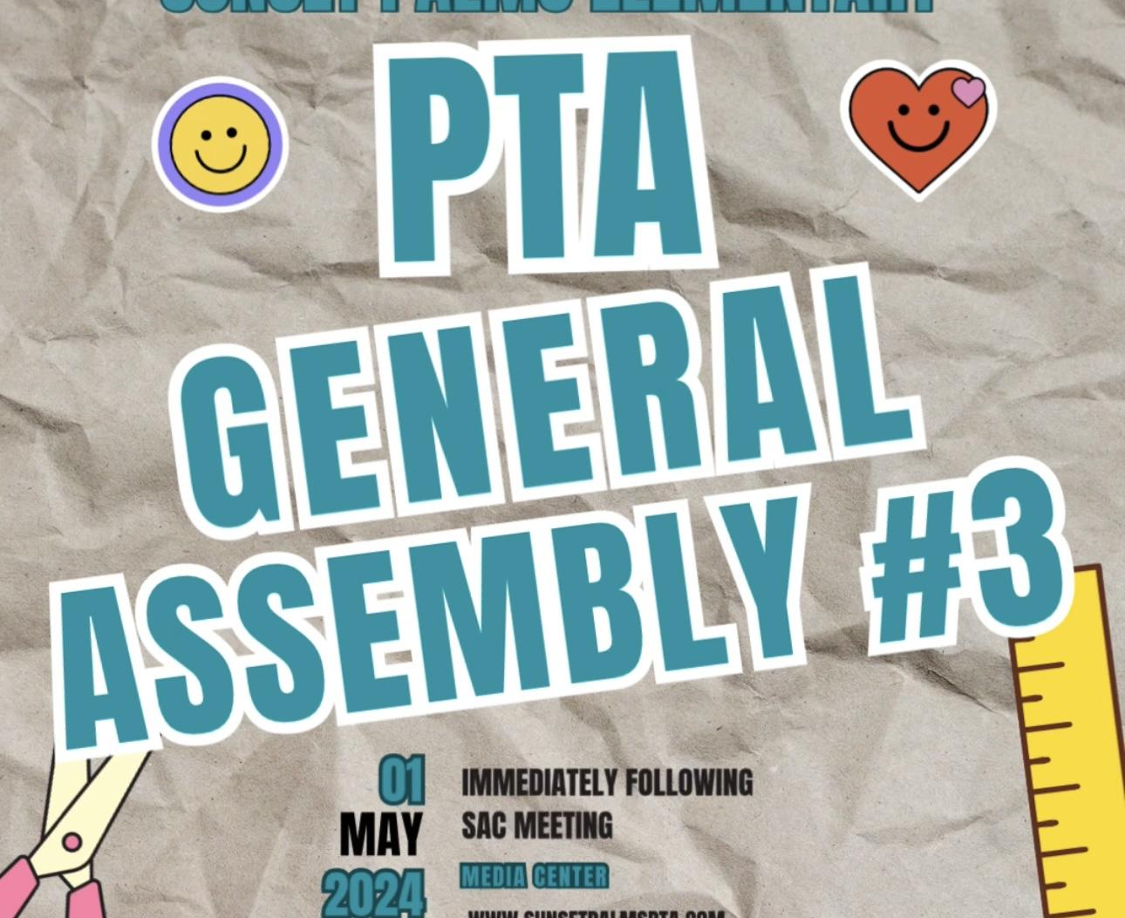  Save the Date for General Assembly #3 on  May 1 in the Media Center! We will be voting on the Executive Board for the 2024-2025 school year.  *********************************************************Calling All Volunteers  PTA is always looking for people to join the team. If you are interested in volunteering with PTA, please reach out to us at volunteers@sunsetpalmspta.com.  *********************************************************  April PTA Events  April 5, 12, 26- School Store  April 10- New Spirit Wear Available on Memberhub  April 19- Spirit Night at Adrenaline 4-8 p.m.  April 19- 5th Grade Yard Sign Deadline | 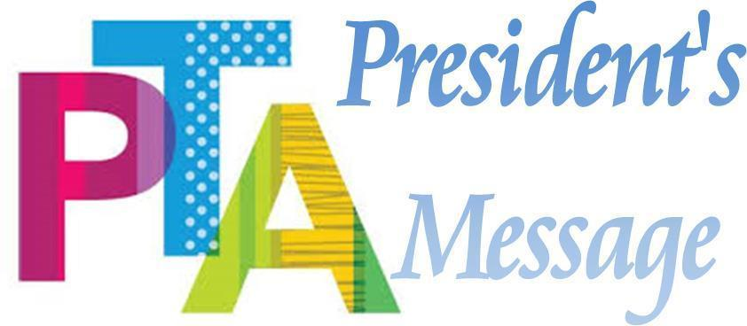  I hope everyone had a fun Spring Break! Thank you to all who came out to support our school for our Scoops Spirit Night last month! We are looking forward to a super exciting Spirit Night at Adrenaline in April!  -Ana Marin, PTA President  *************************************************************  Renew your PTA membership!  Remember that volunteering is NOT required (although always appreciated)! Renew your membership today by scanning the QR code on the left.  *************************************************************  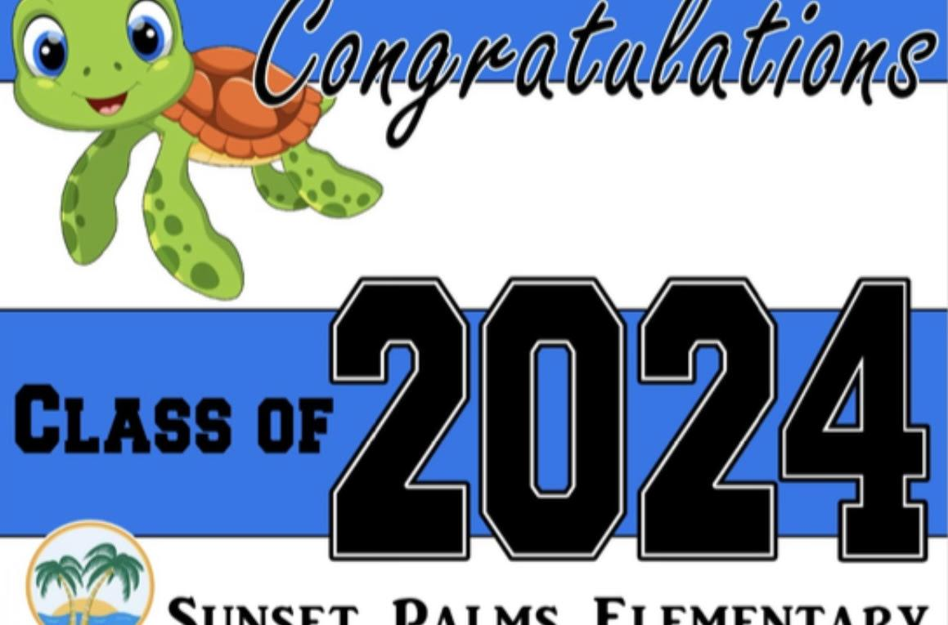  2024 Fifth Grade Yard Sign  Congratulations to our Sunset Palms Elementary Class of 2024! Honor you graduate with a personalized yard sign. Orders may be placed through Memberhub by scanning the QR code to the left.  Deadline to order is April 19.

