Sunset Palms Turtle Talk
Karen Riddle, Principal Justin Gamelin, Assistant Principal Sunset Palms is an “A” rated and 5 Star School October 1, 2023

IMPORTANT PHONE NUMBERS  Main Office 752-1100  Clinic 752-1121 (Nurse Linda)  After the Bell 752-1135 (Mrs. Baumgardner)  ESE Contact 752-1112 (Mrs. Janisko)  Data Processor 752-1102 (Mrs. Hadley)  Guidance 752-1117 (Ms. Marcus)  Cafeteria 752-1156 (Kinia Estime)  Attendance Hotline 752-1160  IMPORTANT DATES  Oct. 2 – Wear Blue for World Day of Bullying Prevention  Oct. 2 to 9 – Book Fair during Media Fine Arts rotation  Oct. 4 – Bike/Walk to School Day  Oct. 4 – SAC Mtg. 2:30 p.m. in Media Center  Oct. 5 – Book Fair Night – 4:00-6:00 p.m.  Oct. 13 - No School for Students – PDD Day  Oct. 18 – Wear Orange for Unity Day  Oct. 20 – PTA Trunk or Treat 5:30-7:30 p.m.  SHOWCASE OF SCHOOLS  The Showcase of Schools will be held at the South Florida Fairgrounds – Expo Center at 9067 Southern Boulevard, on Tuesday, Oct. 17 from 4:00 – 8:00 pm. Over 125 elementary, middle, and high schools offering Choice Programs, District representatives, and community organizations will be present to provide information regarding Choice and Career Academy options. The Showcase of Schools provides valuable resources for families in providing them with information about the District’s Choice Programs so they can make informed decisions when the application opens on Wed., Nov. 1. This event is open to the public free of charge. Families may bring their Food for Families donations to the event.  DISTRICT POLICY/SAFETY  Students may not bring knives to school for any reason, which means please do not pack knives in your student's lunch box to use for lunch or snack.  WATER SAFETY  Water safety is so important for everyone raising children in South Florida, which is why we are sharing the “Be Water Smart” booklets produced by the Drowning Prevention Coalition of Palm Beach County. Inside the booklet, you will find great safety tips as well as locations where you can get swim lessons. Here are the links for versions of the booklets in English, Spanish, and Creole. The booklets were produced by the Drowning Prevention Coalition and its partners.  http://l.sdpbc.net/j6vvb Creole Booklet  http://l.sdpbc.net/7chn5 Spanish Booklet  http://l.sdpbc.net/pfgt0 English Booklet  http://l.sdpbc.net/z6rg8 QR Codes | .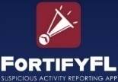  - INSTANTLY ALERT LAW ENFORCEMENT ABOUT SUSPICIOUS ACTIVITY & THREATS  - INCLUDE PHOTOS AND VIDEOS EASILY  - REMAIN ANONYMOUS  See Something, Say Something, DO SOMETHING  ADOPT-A-CLASS  Thank you to the following parents and community members for your support in the Adopt-A-Class Program. Your donation to our students and their learning environment is greatly appreciated!  Abramowitz Family, Julia Alame, Tempany Anderson, Marisa Balestriere, Mariegrace Bartolini, Naomi & Rodger Bernstein, Jennifer Bieber, Lauren & Joseph Blodgett, Nelmarie Bowe, Sondra Braude, Andrea & John Brooks, Meg Buoniconti, Vincent Buoniconti, Matthew Chamberlan, Lauren, Chanley, Michael & Erica Cohen, Lindsay Coppola, Maria Devaynes, Stefanie Eadie, Jade Fink, Stephanie Fishman, Staci & Jonathan Fishman, Dery Fitzpatrick, Carin Foldes, Casey & Benjamin Freedman, Shelly Friedberg, Ilaia, Gadalla, Leonora Geiger-Miller, Hala Ghazali, Lauren Goldblatt, Michael Gordon, Matt & Shara Goudreau, Erin Grandy, Evan Hall, Andrea Hammad, Monka Hanko of Eurotransport and Moving, Inc., Teri Harris, Richard & Maria Hart, Katie & Max Hood, Noelle Ilchert, Seth & Shelley Jacknowitz, Marni Jacob, Anneke & Zac Johnson, Heather Kalin of Animal Edventures, Jenna & Adam Kaplan, Hitesh & Daya Kapupara, Emily Katcher, Jacki & Brian Kay, Jane Kaye, Bari Kellam, Chris Kellam, Brian Kirey of Brilliant Pottery Home Decors Inc., South Pacific Shipping Inc & Pottery Merchant USA, Prasanna Kolli, Heidi & Adam Kwiatkowski, John Lallo of Forest Hill Family Orthodontics, Steven Lazarus of Promotional Breezes, Inc., Kim & Chris Legg, Jonathan Majak, Casey & Jon Levin, Maya Levine, Kerry Lightcap, Bari Litt, Aaron Magee, Jamie Mann of ABSee Me Read Tutoring, LLC, Jessica Martin, Mary Ellen Mazer, Jay & Michelle Ragusa-McBain, Raelynn Miller, Tracii Miller, Briquell Morales, Brendan & Lauren Morris of More is Morris Designs, LLC, Ehrlich & Naperstek, Injury Trial Lawyer, Nicole Oden, Victor Oramas & Ada Seminario, Maria Pacquee, Margo & Scott Pepper, Nicole Perry, Christina Pierro, Erica Raetzel, Rachael Ramas of Rama Law, Danielle Reece, Carly & David Rivadeneira, Kim & Nick Rosenblatt, Missy Rosenblum of Sweet Missy’s, Santiago Family, Meredith Schulere, Ilyssa Silver, Simpli-Fi AV, Dr. Aruna Singh, Jasset Smith, Emanuel Soare, Elissa & Justin Sorel, Diana Spielman, My Stanton, Brett Steinberg of Steinberg Law, Meredith Steinhaus, Meredith Tanen, Carol Tessel, Dara Thorne, Samantha Thomas, Karen Vieira & Zack Preble, Antonia Shrayev, Shan Thayyullathil, Antonino Vento, Jill Webb, Robert & Amanda Weingard, Farrah Weiss, Andre Yospe.  SCHOOL WEBSITE LINK  http://www.palmbeachschools.org/sunsetpalmselementary | NEW WORLDS READING, FLORIDA’S FREE BOOK DELIVERY PROGRAM  New Worlds Reading mails free books and activities to eligible children to help strengthen their literacy skills, build reading confidence and nurture a lifelong love of reading. Once enrolled, students will automatically receive free books and resources through fifth grade, even if their reading scores improve.  New Worlds Reading is administered by the University of Florida Lastinger Center for Learning, which has selected Scholastic as a partner. Books are selected in collaboration with the Florida Department of Education, with materials available in English, Spanish, Haitian Creole or braille. This is an incredible opportunity to help your child build a free personalized at-home library and foster a love for reading in your home. To be eligible, students must be either a VPK student who is not making age-appropriate progress according to state assessment results or a K-5th grade student who is not yet reading on grade level in a public or charter school. Apply for your child today by visiting newworldsreading.com/enroll. We recommend that you submit the enrollment form whether you know your child will qualify or not. New Worlds Reading will make the eligibility determination and communicate directly with you. Additionally, you can email the program directly at support@newworldsreading.com. Thank you for continuing to encourage your child’s love of reading!  RED RIBBON WEEK ACTIVITIES  We will be celebrating Red Ribbon Week from Wednesday, October 25, 2023 – Tuesday, October 31, 2023. This annual event is designed to encourage students to make wise decisions and healthy choices regarding drugs. Each day we will have a different theme or activity to  help our students get into the spirit! The National Red Ribbon Week theme supported by the school district is: “Be Kind to Your Mind-Live Drug Free”.  The schedule for the week is as follows:  Wednesday, October 25, 2023 -“Be Kind to Your Mind-Live Drug Free” - “Think” about kindness! Students and staff may wear a kindness t-shirt or positive saying.  Thursday, October 26, 2023 -“Say Peace Out to Drugs”- Students and staff can wear their favorite tie-dye shirt/outfit.  Friday, October 27, 2023 -“Color My World Drug Free”- Students and staff will wear the colors of the rainbow.  Fifth Grade-Red Second Grade-Green  Fourth Grade-Orange First Grade-Blue  Third Grade-Yellow Kindergarten-Purple  Monday, October 30, 2023 -“Team Up Against Drugs” – Students and staff may wear their favorite sports team attire including a ball cap (no cleats).  Tuesday, October 31, 2023 -“My Character Shines, I’m Drug Free” - dress up as your favorite storybook character.  -OR- “My Future Is Bright, No Drugs In Sight” - dress up as your favorite career.
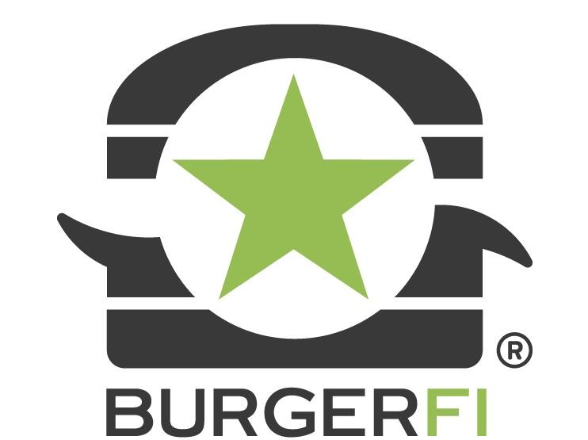  Spirit Night at Burger-Fi!  Join us for Spirit Night at Burger-Fi in Cobblestone Plaza on Thursday, October 12, 2023 from 4:00 – 8:00 p.m.!  A percentage of the sales will be donated back to Sunset Palms Elementary.  Thank you for supporting our school!  ******************************************************  October PTA Events  October 1-15 - Pre-order Howl-o-Ween Spooktacular tickets  October 2- Reflections Starts  October 2-9 - Book Fair  October 12 - Spirit Night at Burger-Fi  October 20 - Howl-o-Ween Spooktacular  October 27 - Student Store  ******************************************************  Calling All Volunteers!  PTA is always looking for people to help with PTA events. If you are interested in volunteering with PTA, please reach out to us at info@sunsetpalmspta.com.  *****************************************************  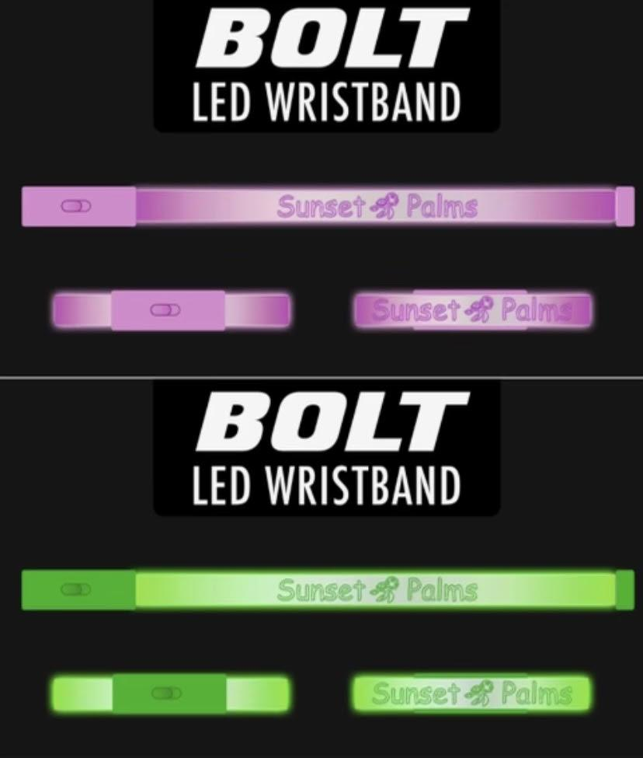  Halloween Grams  Surprise your child with a special Halloween gram! Gram includes a bolt glowing bracelet. Orders can be placed online October 2-13.  ******************************************************  Let’s Stay Connected!  Visit our website: www.SunsetPalmsPTA.com  Sign up for our emails: Text SPEPTAINFO to 22828  LIKE AND FOLLOW US ON SOCIAL MEDIA! | PTA NEWS  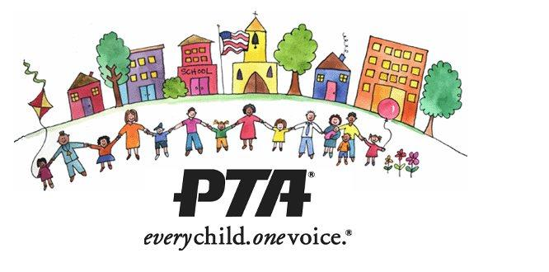  **********************************************************  Howl-o-Ween Spooktacular  Save the date! Our super fun Howl-o-Ween Spooktacular event is October 20 from 5:30-7:30 p.m.! We will have a DJ, food trucks and trunk-or-treating.  Scan the QR code to pre-order your tickets online 10/1 through 10/15.  If you would like to volunteer your car to be one of our Trunk-or-Treat cars, please scan the QR code to register. Space is limited.  **********************************************************  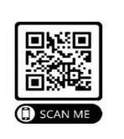  School Spirit Items  Scan the QR code to visit PTA’s online store to purchase Spirit Wear, Polo Shirts, Birthday Grams, Halloween Grams and Howl-o-Ween Spooktacular event tickets!  For questions regarding orders please reach out to spe.ptaorders@gmail.com . | 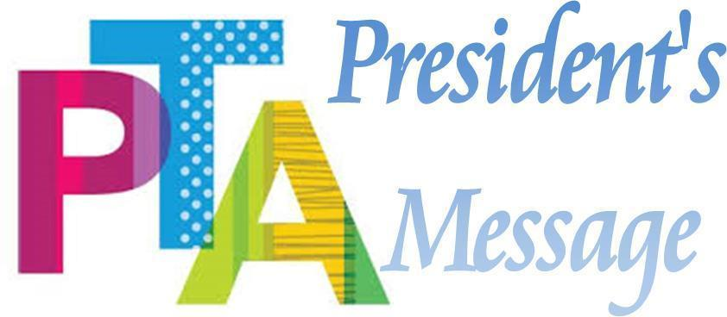  What a great start to the new year Sea Turtle family! Thank you to everyone who was able to join us for BINGO night, and to those who participated in our spirit nights and our new Buddy-a-Thon fundraiser. We cannot wait to see everyone at our Howl-o-Ween Spooktacular event this month!  Sincerely,  Ana Marin, PTA President  *************************************************************  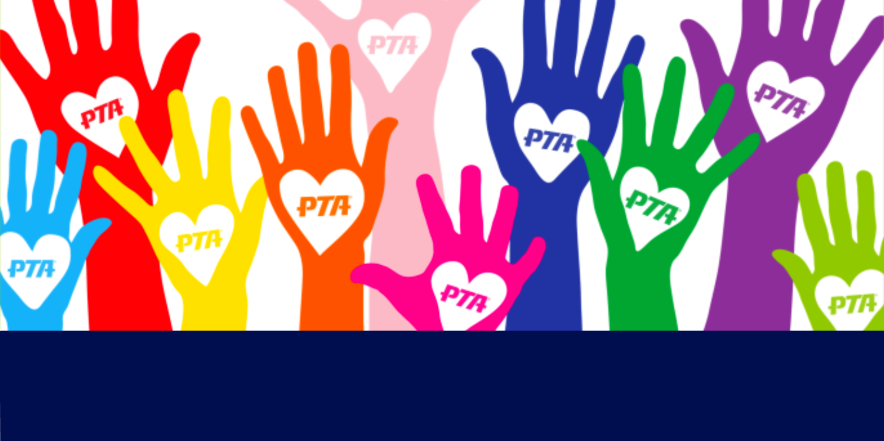  Become a member of PTA!  It is not too late to join PTA for the 2023-2024 school year! Download your membership form at www.SunsetPalmsPTA.com.  *************************************************************  Student Store  Our Student Store is open for business on Friday, October 27 from 7:25 a.m.-7:50 a.m. at the back of the Main Hall, offering Spirit Sticks, Smencils, Smickers, Scented Gel Pens, cute erasers, fun fidgets and more. Check social media for new offerings every month!  *This is a student only event*

